Attachment 2. Application Procedure

(1)Register and login application website http://admission.swufe.edu.cn/member/login.do
(2)Complete and upload all required documents at online application website. Please combine other supporting documents into one PDF File and upload to the position of Reference Letter (see instruction in the picture below).
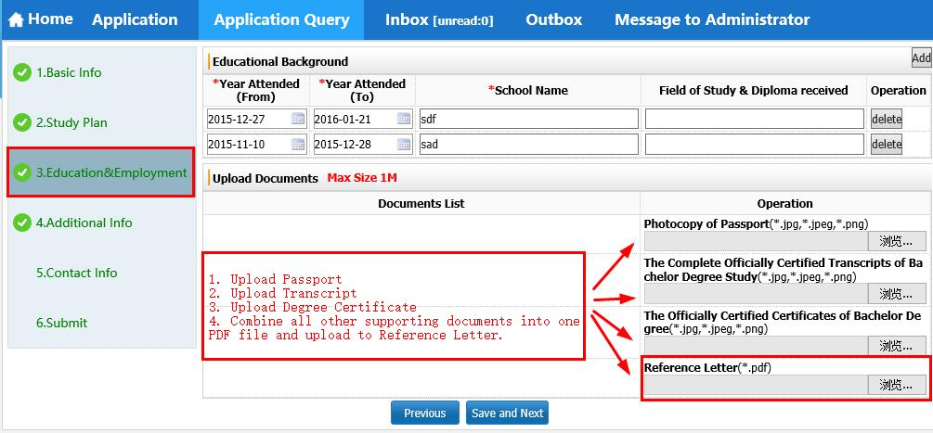
(3)Fill out Financial Supporter as “SWUFE President Scholarship”

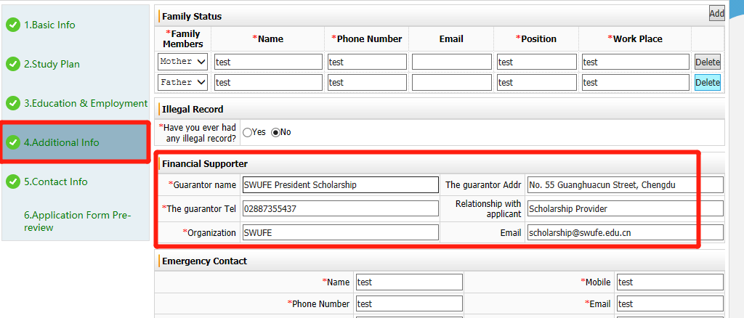
(4)Submit Online Application

(5)After you submit your application, you need to pay application fee RMB 600 online.
